# Installing XAMPP and HeidiSQL

This document is a walkthrough through the process of **installing and configuring XAMPP and HeidiSQL**

This lab is part of the ["Programming Fundamentals" course @ SoftUni](https://softuni.bg/courses/programming-fundamentals).

**XAMPP** is a completely free, easy to install Apache distribution containing MariaDB, PHP, and Perl. The XAMPP open source package has been set up to be incredibly easy to install and to use.

# Installing XAMPP and Configuring MySQL Database

This first part will show you how to **install XAMPP** and **create your first MySQL DB**.

## Downloading XAMPP

Download XAMPP from <https://www.apachefriends.org/download.html>.

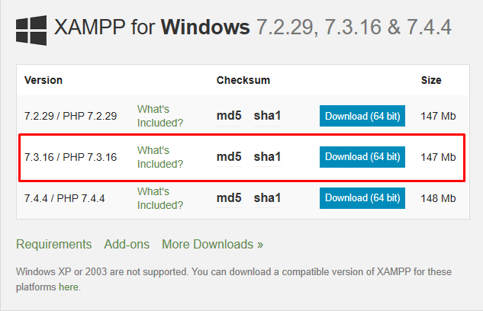

## Installing XAMPP

The pictures below will show you the steps that you need to go through, in order to successfully install XAMPP.

Install XAMPP in the **default directory** ("C:\xampp"), or you might encounter permission troubles later on.

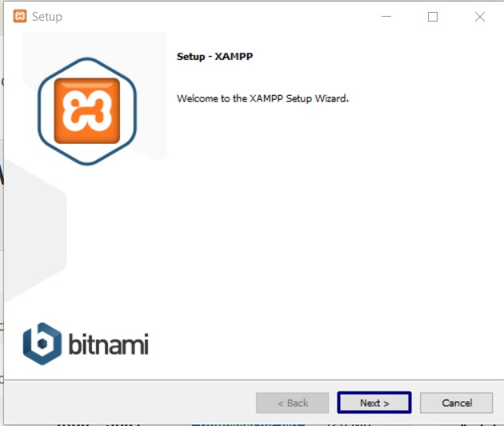

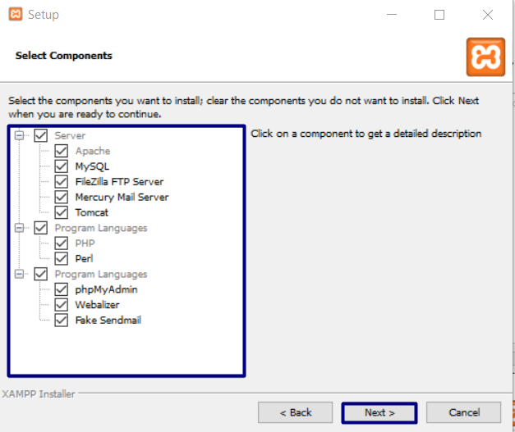

If you are not in the **PHP Track**, you can select only MySQL:

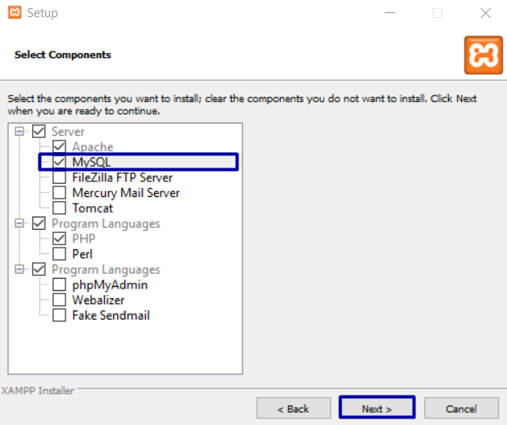

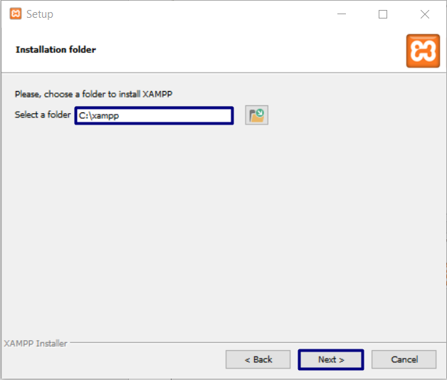

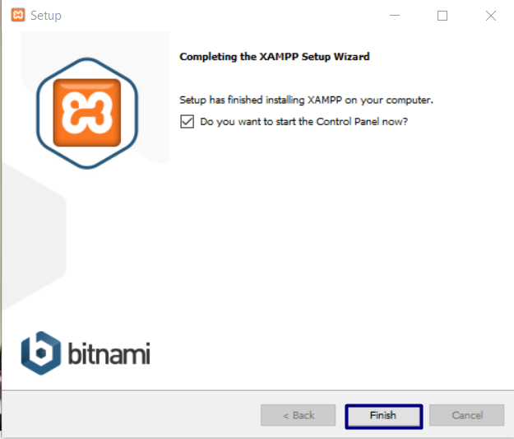

## XAMPP First Start

The first time you **start XAMPP** you will get **language selection screen** like this one:

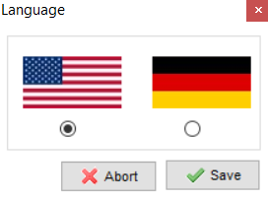

After you choose the language you prefer, you will see the **main screen of XAMPP**:

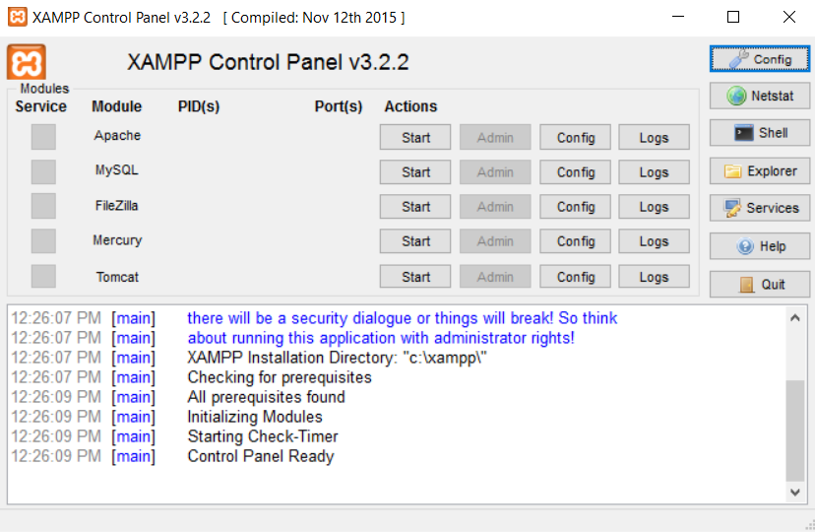

## Start MySql Database

Now we need to **start MySql Database**:

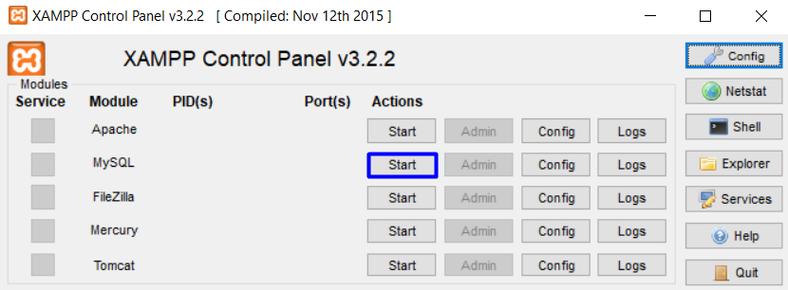

If everything is correct, the **MySql** label will become green, and you will see the default **ports** – **3306**.

# Installing HeidiSQL

Before you start you can download [HeidiSQL](https://www.heidisql.com/) from [here](https://www.heidisql.com/download.php). "**Heidi**" allows you to see and edit data and structures from databases. You can install the **tool** by clicking next, next, next…

When you open **Heidi,** you are going to see this:

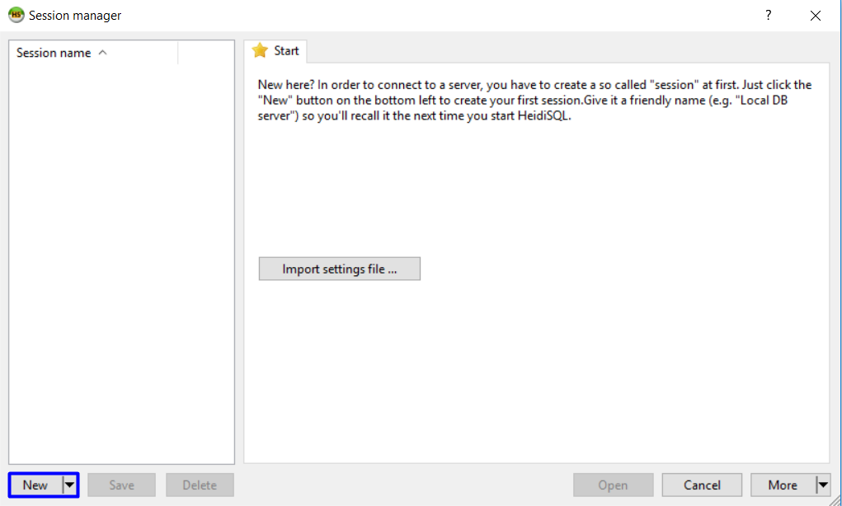

You can create a new session (click on "New") and open it. Then you can manage your databases:

